**High Level Design Document**

|  |  |
| --- | --- |
| **Project Name** | **FlightCoach-TKCS** |
| **Client Name** | **FlightCoach** |

##### Chetu Contacts

This section should list all Chetu team members.

Note: All Chetu emails are of the format: FirstnameLastnameinitial@chetu.com

Note: Chetu (US) team works normal hours EDT and can be reached at: 954 342 5676.

Note: Chetu (India) team works 5am-2pm EDT and can be reached at: 954 862 3901.

|  |  |  |  |
| --- | --- | --- | --- |
| Name | Role | Location | Responsibility |
| Anshu Singh | TM(UI/UX) | India | Developer |
| Satish Kumar | TL(UI/UX) | India | Architecture and design  Development, guiding TM |
| Manish Singh | TM(Embedded) | India | Developer |
| Suraj Pandit | TL(Embedded) | India | Architecture and design  Development, guiding TM |
| Shashi Das2 | PM | UK | Overall project management |
| Sanjeev Kota | DO | USA | Managing project delivery and operations |

##### Client Contacts

This section should list all customer contacts including project champion and business users.

|  |  |  |  |
| --- | --- | --- | --- |
| Name | Email | Entity | Responsibility |
| Jeff Cass | jeff@jeffcass.com |  | DO/PM POC |

##### Revision Chart

A new record should be added every time a user updates this document.

|  |  |  |  |
| --- | --- | --- | --- |
| Ver. # | Date | Author | Change |
| v.04122023 | 04/12/2023 | Shashi Das | Initial draft |
|  |  |  |  |
|  |  |  |  |
|  |  |  |  |
|  |  |  |  |
|  |  |  |  |
|  |  |  |  |

##### Document Conventions

* *Notations in Italics contain Document instructions and should be preserved*.
* Sections highlighted in **yellow** shall be provided by Client.
* Sections highlighted in **grey** are questions or open items that need to be discussed further.

Contents

1.0 Introduction 5

1.1 Overview 5

1.2 Project Objectives 5

1.3 References 5

1.3.1 Industry Specific 5

1.3.2 Project Specific 5

2.0 Requirements recap 6

2.1 Overview 6

2.2 Details 6

3.0 Glossary of Terms 7

3.1 Industry Specific 7

3.2 Project Specific 7

4.0 System Architecture 8

5.0 Functional architecture 9

5.1 Overview 9

5.2 [Functional Module Name] 9

5.2.1 Overview 9

5.2.2 Component level details for this module 9

6.0 Project Guidelines 10

6.1 Environment 10

6.1.1 Description 10

6.2 N-Tier Architecture 10

6.2.1 Overview 10

6.2.2 Description 10

6.3 Coding Module Hierarchy and Breakdown 10

6.3.1 Description 10

6.4 Coding Standards 11

6.4.1 Description 11

6.5 RAD components 11

6.5.1 Overview 11

6.5.2 Description 11

# Introduction

## Overview

FlightCoach is a new customer in IOT Industry. Customer is working on his own custom Thermostat that will solve many of the issues like controlling and monitoring Temperature, Humidity, CO2 (Carbon Dioxide) and CO (Carbon Monoxide). He is still in the process of creating a prototype that will have a 7” TouchScreen Display to control these parameters and involves relevant sensors and devices.

## Project Objectives

We need to work on two different parts of this Thermostat application. 1. **UI/UX** 2. **Embedded.**  With the help of these technology we are building heating, central heating, air conditioners, HVAC systems, water heaters, as well as kitchen equipment including ovens and refrigerators and medical and scientific incubators.

## References

### Industry Specific

<https://en.wikipedia.org/wiki/Internet_of_things>

### Project Specific

N/A

# Requirements recap

## Overview

Customer has two part of work and he wanted to start parallel: 1. **UI/UX:** Client wants us to create a complete design for all the possible screens to be displayed on their 7” Touch Screen Monitor. He has provided the list of pages that we need to work on and will also provide some high level sketches for us to follow. 2. **Embedded:** We need to start analyzing the Specification documentation and Datasheets for the hardware he plans to use, and start working on the Firmware development.

## Details

There are (6) main operational modes of heating/cooling/dehumidifying and (2) modes for fan operation. Listed are the operational modes followed by a more detailed sequence of operation for each. Separately I’ll send a wiring connection diagram to aid in understanding. Additionally, there are multiple operational characteristics of each mode based on installer setup choices and will be discussed Later.

# Glossary of Terms

## Industry Specific

N/A.

## Project Specific

N/A

# System Architecture

*.*

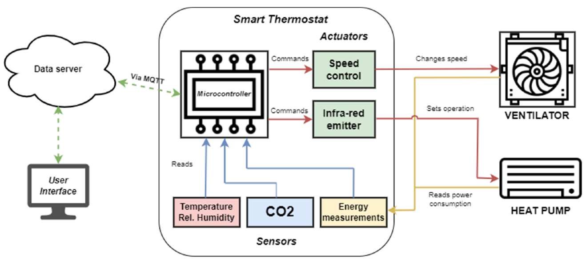

The presented smart thermostat is part of an internet of things (IOT) system of distributed modules and sensors. The architecture was defined to ensure ease of integration and scalability of the solution. These modules communicate via Message Queuing Telemetry Transport (MQTT).

The main purpose of the smart thermostat is to monitor and control air quality and thermal comfort inside rooms, as well as to be integrated into the building microgrid and pursue energy efficiency and demand control measures. The control software of the smart thermostat can be programmed to schedule the heating or cooling of a room, as well as to maintain air quality by keeping a CO2 concentration below a defined threshold. The system can include multiple smart thermostats installed in the same building, and is connected to the building management system that coordinates operation to ensure energy demand flexibility, for instance, in response to a high (or low) tariff period, a PV generation surplus period or a peak demand period. The smart thermostat is constituted by several modules with different tasks, as presented in above diagram.

# Functional architecture

## Overview

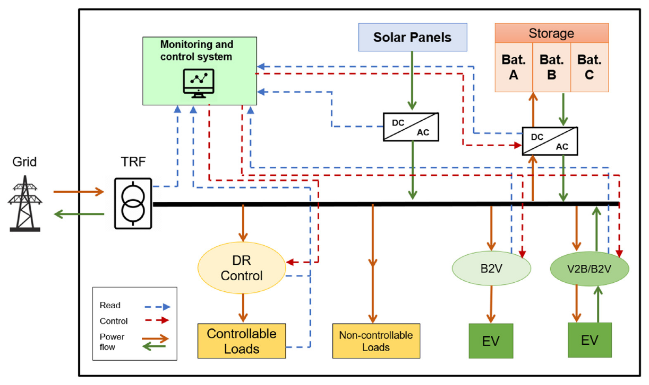

The smart thermostat is being implemented in an existing university campus microgrid. The microgrid is located in the Department of Electrical and Computer Engineering of the University of Coimbra. Figure 2 presents the existing microgrid, as well as the power flow and the information pathways that control the system.

Currently, the microgrid is comprised of a PV generation system, a battery storage system (27.9 kWh), grid-to-vehicle and vehicle-to-grid ready chargers, as well as a monitoring and control system.

# Project Guidelines

Used Technology and Tools:

## Environment

### Description

|  |  |
| --- | --- |
| Technology/Tool | Description |
| Embedded C | Embedded C is a set of language extensions for the C programming language by the C Standards Committee to address commonality issues that exist between C extensions for different embedded systems. |
| Database | PGSQL |
| Development Tool | VSCode and edinoid. |
| Display | nextion-editor. |

## Embedded System Programming Architecture

### Overview

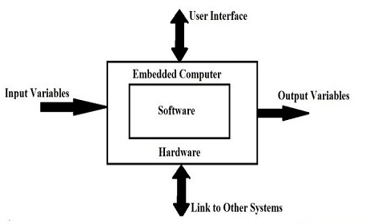

### Description

The following are the components of embedded systems

* **Embedded Hardware:** The micro-controller is the heart of the embedded system, where multiple peripherals are interfaced to embedded hardware for communication purposes.
* **Embedded RTO’s:** An embedded real-time operating system is used to perform all complex (ar operations.
* **Device Drivers:** It acts as a bridge between the operating systems and peripheral devices.
* **Communication stacks:** It is used for communicating with external devices.
* **Embedded applications:** It performs the predefined function of the embedded device.

## Coding Module Hierarchy and Breakdown

### Description

Working on defined coding standard as per Android industry standard*.*

## Coding Standards

### Description

Working on defined coding standard as per IOS industry standard*.*

## RAD components

N/A